Student Support Initiative Award 2017

Get Ready for College pre-entry course

Student Support team Perth College UHI

1) Outline the project or initiative and what makes it innovative and inspiring (max 300 words).

Our project is called Get Ready for College and it is a bespoke pre-entry course. The programme aims to give students an insight into college life and prepare them for starting their chosen course. The main aim of this induction is to help students to feel more comfortable in the College environment and make the move to college easier.

This course is specifically aimed at students who have been highlighted either by our Transitions Officer, external agencies or direct from schools. Candidates for this course tend to be young people who have had attendance issues at school, experience anxieties, are from care experienced backgrounds or have additional support needs.

Students who have been identified are then given the opportunity to familiarise themselves with their surroundings. They can meet key staff members and potentially other young people who may be studying on the same or similar course. Students are then equipped to go on to achieve their goals and fulfil their potential.

By looking at feedback collected over previous years we have adapted the course. We are always looking at new and inspiring ways to deliver and have an awareness of the diverse range of needs that the students who come onto the course have. We aim to revise the course including the content, format and location. We now have an ideal location within the Student Support Hub to hold the inductions. Going forward we aim to adopt a person-centred and relaxed approach to the Get Ready for College course including tours and use of the Hub.

2) Detail how the project or initiative was delivered, from the planning stage through to its successful conclusion (max 300 words). Include details of timing* and funding.

Planning for Get Ready for College starts as early as May. Names and contact details for students start to come in from schools and from our Transitions Officer at this time. Young people identified as having additional support needs are passed to us and a list is then generated and names will come in to be added to this list during the summer holidays.

The students are then split into two lists, those with conditional and unconditional offers. We send letters out to these separate groups to invite them onto the course. Once we receive responses we form two separate groups based on their prospective courses.

Course content and format is discussed In April. Any changes based on previous feedback are then incorporated into the formation of the course. As previously stated this course needs to suit a vast range of learning needs. The course is run over 3 days in August. The date for Get Ready for College is usually two weeks before Semester one starts. This ensures that the campus is quiet for the delivery and tours to take place. Allowing the students to explore the campus prior to the start of the semester is essential as it allows them time to gain confidence.

Items to be funded for this project include juice, biscuits and snacks for each class and day, resources for use in classes including paper, pens, post-it notes and photocopying charges.

We generate registers for each class and day so that we know who attended. At the end of the course we ask the students to complete a feedback form. During feedback we ask if they have enjoyed the course, how confident they feel prior to the course and if there is anything else they would have liked to have been shown or told.

3) Outline the project or initiative’s outcome(s) within the university and beyond with relevant supporting evidence, metrics or testimony where appropriate (max 400 words).

- Provide a bespoke pre-entry course for an identified group
- To collate feedback and make improvements for future projects

The main outcome of the Get Ready for College project is to equip this identified group with the knowledge and skills necessary to start their college experience in a positive way. This course breaks down potential barriers which if not recognised could prevent these students from starting college.

We formed a brochure which we give to each student on arrival. This is packed full of useful information which they will need prior to starting college. It includes details of the buildings on campus, contact details and photographs of all key staff members, details of what they can expect from the student support team, a FAQ page, directions to and from the campus and a map. This brochure is updated each year to provide current and relevant information. Below are 2 extracts from the brochure.

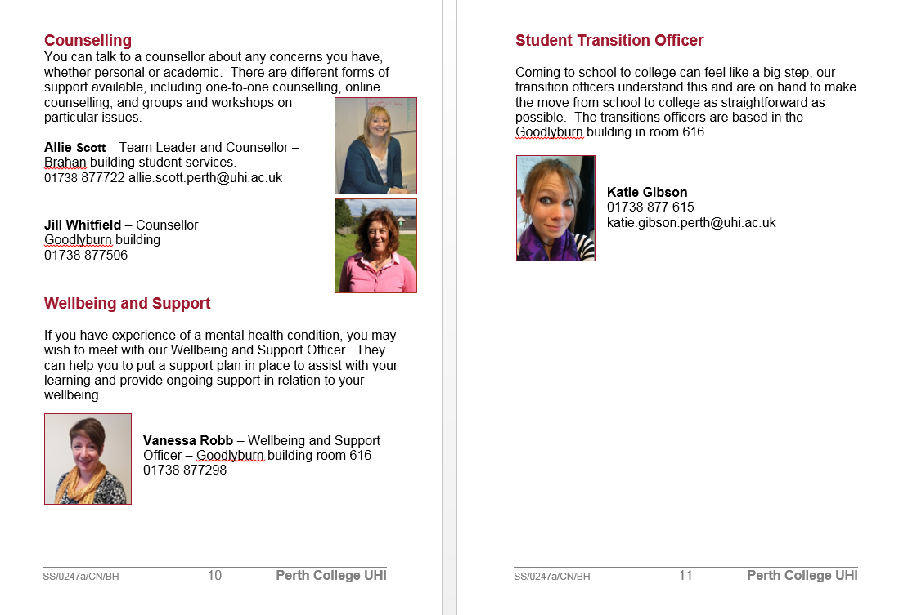

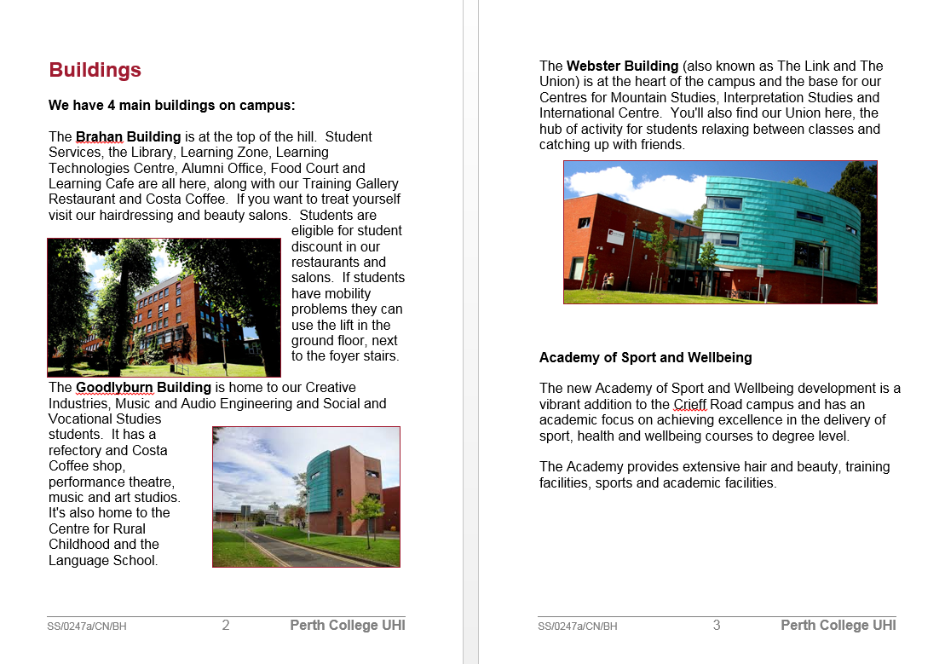

Gaining feedback at the end of the course is extremely important for us. We are looking to gauge the thoughts and opinions of students from the course delivered in 2016/17 to help us to create the structure for next year’s course.

Feedback received from the 2016/17 induction included;

Do you think you learnt something new, if so what?

‘I learnt about who to go to for what if I have a problem’.
‘I learnt more on where things are and where to go’.
‘I feel very confident because I have met a lot of new people’.
‘I’ve learnt the meaning of resilience’.

What could we change?;

‘Do more of a tour’.
‘Possibly mixing seats here and there’.

As can be seen from the feedback above, our Get Ready for College aims to fulfil the needs of a specific target audience. It provides the basic information necessary to enable this group to build confidence, meet key staff members and familiarise themselves with the campus prior to the standard student induction.

Claire Nelson, Student Support Worker – Perth College UHI

