**Student Support Initiative award 2018**

**Outline the project or initiative and what makes it inspiring**

At Moray College we have always had close links with the Moray Food Bank who have provided an invaluable service to our students when required. The college had noticed an increase in provision with the onset of “Universal Credit” and had left students worse off than under previous benefit systems. The Food Bank offered a discreet service where food parcels were delivered to main reception and student could pick up in Campus. We were approached by The Foodbank who wished to enhance our partnership and better serve the students by setting up a “Community Larder” which offers dignity and choice in crisis food provision. The larder is based in the college in a private area where students who are referred can come and actually choose their own foods to their liking and taste, rather than being handed a bag of unknown foods which might not suit dietary requirements. This Empowers the student with choice, in what is a very sensitive and stigma orientated situation.

The project has been further enhanced with working together with Hospitality department holding 2 free breakfasts and a lunch using food from Moray Food Hub (this takes quality supermarket waste and other surplus foods and redistributes to community groups and other food related projects). It is well documented that with poverty there is a large proportion of people suffer Mental Health difficulties and the project is now going into the next phase creating a meditation and wellness garden with the help of Horticulture students. Funding shall be shared from a Foodbank project and college funds and will help with materials and provision of a therapeutic gardener. The students can volunteer to work in the garden as a help for their Mental Health or they can enjoy after it is complete. The project is inspiring on so many levels and vulnerable people are now supported in even better ways than we could previously have imagined. We have made others aware of food poverty in Moray who otherwise may not have been aware of what this is and the affect it can have.

**Detail how the project or initiative was delivered, from the planning stage through to its successful conclusion.**

Discussions about the possibility of project took place in summer of 2017 with the Student Advice Manager, Foodbank and Hospitality staff. An area was found for the community larder where it was discreet and accessible for students. The foodbank delivered foodstuffs, ladies sanitary products and toiletries to fill the larder. This was available at the start of term. Hospitality staff were able to timetable first of the breakfasts in December once the students were confident to deliver this independently from the staff. The students worked with the Foodbank staff to co-ordinate and decide what would be cooked depending on the food that was made available from the Moray Food Hub. The breakfasts and subsequently lunch were advertised on social media and around the college. Anyone attending the breakfasts were asked for donations. The breakfast and particularly the lunch were very well attended. The three events so far have raised £500.00 for the Foodbank. The first breakfast took place in December 2017.

After the first breakfast the Higher Sociology students wanted to engage with the project and they are now currently designing an information poster that could be condensed into a flyer to be given out at future breakfasts.

Research indicates that poverty and Mental Health issues are inter related, we looked at how we could support this. In the first instance we were going to have a plot to grow vegetables supported by foodbank users, but we did not meet the criteria to obtain funding from lottery fund. There was another pot of money we could tap into through the foodbank if we were supporting Mental Health. We then decided creating a wellness garden where students could help create the garden as a form of therapy with therapeutic gardener and support from Horticulture department. The feedback from students about this part of the project has been very positive. Currently waiting to hear about bid, even if this is unsuccessful we shall work with Horticulture department on wellness garden with college funds.

**Outline the project or initiative outcomes and what makes it innovative within the university and beyond with relevant supporting evidence, metrics or testimony where appropriate.**

The focus of the project was to create awareness of food poverty in Moray, what is being done to help and how the college can contribute to this. It was also intended to help feed students.

We have within the college created an environment where there is now knowledge of The Moray Foodbank, how it helps people (1929 Adults in Moray/830 Children) and utilise foods that normally would go to waste. 115,000 tonnes of good food being dumped by our supermarkets, it seems incredulous to think there are people going hungry. This is where the Foodbank and Moray college partnership has helped change this albeit in a small way, but the project is in its infancy.

The awareness has encouraged students to help with the project outside the Hospitality and Horticulture departments, Higher Sociology students were so impressed with the project they wanted to help out and have been asked to produce an information poster that could be condensed into a flyer. They will cover

* The causes of poverty in Scotland and /or Moray
* The extent of Poverty in Moray
* What the foodbank does and why it exists
* What impact it is having (limited research- only 4 weeks to get finished)
* What role education plays in terms of highlighting the problem, educating people to understand the extent of the problem
* Some limited coverage to the benefits system

The posters and flyers shall be finished by the first week after Easter.

On review of breakfast and Lunch it was shown that more staff and outsiders were benefiting from it than the students who we had originally wished to feed. On reflection we have looked at location which currently is in the Beechtree main restaurant. We have therefore decided to move the breakfasts to the café area at reception to encourage more students to come into perhaps a more relaxed informal setting.

On the success of this, the Foodbank are now in discussions to see if a group of students would come and cook externally in a church hall for a lunch club using Moray Food Hub food.

Food poverty is the result of a complex set of issues relating to problems of insecure, inadequate and expensive housing, insecure and low paid employment, insufficient social welfare provision, poor health, and an environmentally unsustainable and socially unjust food production and distribution system. In order to begin to address food poverty it is important that a broad range of partners come together to work together to make Moray a more equal society and Moray College is helping to make an impact in its own small way.

**APENDICE OF EVIDENCE**

**Quotes after Breakfasts and lunch:**

*"Super food, I can't believe the students were able to make such a variety of tasty dishes from food that would otherwise have been thrown away by the supermarket's"  - member of the public who attended the college lunch event*

*"I would love to see more of these event's. It's a struggle to afford a decent lunch every day when you are a student.  I really like that it's other students that are trying to help each other " - Moray College student who attended the lunch event*

*"Great idea to offer a free breakfast for students who have to travel in early to college and don't get time to grab anything to eat"  Moray College student who attended the breakfast event.*

*"This is a great idea, it's a concern for staff when we know students are struggling financially as it has such a negative knock on effect to their learning" Lecturer, Moray College*

*"Brilliant to see the catering students so enthusiastic about cooking their own food and coming up with their own ideas"  Catering Lecturer, Moray College*

**Testimony from Foodbank**

*As a Foodbank, we are aware that many students can experience financial hardship while completing their studies. To address this, the Moray Foodbank were keen to work in partnership with Moray College students to enable them to provide peer support through communal eating, ensuring it was led by the students for the students. After a series of meetings between the Moray Foodbank development worker, college staff and five catering students, it was agreed to hold a series of lunch and breakfast events. The students suggested making the lunch events pay as you want to raise funds and allow them to offer a free breakfast one a month and we felt this was a fantastic idea.  The Foodbank have been delighted to support the students to so far, have held one lunch event and two breakfast events which have been a huge success.*

*These events have provided a great starting point for the students in particular, gaining valuable insight and learning that they will use to continue to develop this project further. The students are enthusiastic to use this knowledge to look at new ideas such as takeaway boxes for their fellow student's, as well as seeing the need to encourage other students with other skills other than cooking, to get involved and continue to keep the momentum going.  We are also currently exploring the possibility of community kitchens in partnership with the college and local churches.  The hope is the students again, will very much be at the heart of the project to not only continue to support each other with food but become involved in feeding their own community through communal meals and most importantly raise the social value of food.*

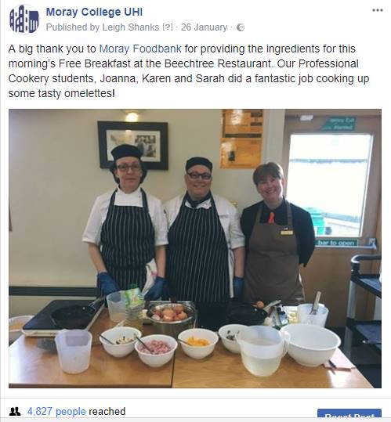

Fantastic omelette this morning thank you https://static.xx.fbcdn.net/images/emoji.php/v9/ffc/1/16/1f44d.png👍

Enjoyed my breakfast this morning my omelette was amazing thank you.

Well done guys x

Nice one Sis, proud of you. xxx

Omelette was amazing!

Just fab!! Italy won't know what hits it Karen!!!

Well done .xx

Looking good. https://static.xx.fbcdn.net/images/emoji.php/v9/fb7/1/16/1f917.png🤗

Well done to all concerned esp my lovely daughter Sarah who one day in the near future will cook an omelette for her frail old dad, won’t you Sarah dearest. https://static.xx.fbcdn.net/images/emoji.php/v9/fd7/1/16/1f35a.png🍚https://static.xx.fbcdn.net/images/emoji.php/v9/f91/1/16/2615.png☕️https://static.xx.fbcdn.net/images/emoji.php/v9/f98/1/16/1f37d.png🍽https://static.xx.fbcdn.net/images/emoji.php/v9/fd2/1/16/1f967.png🥧https://static.xx.fbcdn.net/images/emoji.php/v9/f5/1/16/1f382.png🎂

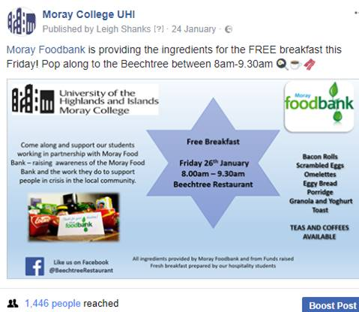

**Lunch Menu using food from Community Hub**

American themed buffet included:

cowboy soup

creamy chowder soup

turkey socctash

mac and cheese

chilli

cauliflower and cheese

macaroni burger

spicy bean burger

pulled chicken

onion rings

cheese wedges

salt and pepper wedges

waffles chicken and ham

bread and butter pudding

**Response from Students to Wellbeing Garden**

*“This is a really good idea.*

*Let me know if there’s anything I could do to help.”*

*“I think the garden is a fantastic idea. Being outside and within green nature spaces has an amazing and positive effect on your mind. (From someone who has suffered anxiety and knows it works)”*

*“ I would be very interested in helping in any way I can in the making of a Wellness Garden. I am incorporating the well being of gardens in a small project which I am doing at the moment, within the Moray College as a student.  I also have many years experience as a Registered Mental Nurse, and would not hesitate to help out in any way promoting this very important service”*

*“It sounds like a lovely idea to me, unfortunately I can't commit to helping in the creation in the immediate future (also I do not have a good reputation with living flowers). I hope you get enough feedback and volunteers to make this happen.”  
  
“I think this is a great idea and would love to get involved.”*

*“I will be going up to the biblical gardens on Friday to talk to Horticultural students about sustainability and seeing what ideas they have as they have expressed a desire to get involved.*

*I have also been looking at the grounds around the college for an area that we can make more environmental friendly and more enjoyable to use, I've been told to talk to Nick as he organises the plans for works that students do.*

*If I can do anymore to help, please let me know.”*

*“Great idea! I might not be into much of the gardening side but will really appreciate a nicely maintained garden to go to and relax”*

*“Happy to help squeeze some money out of HISA too”*

Bottom of Form