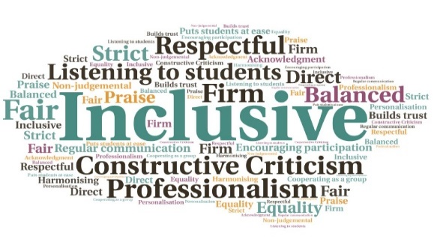  “The free meals have saved me about £15 a week which I use as fuel money for getting here. I have to stretch my bursary to cover my rent, car and food which is challenging. Before I sometimes went without lunch, or my friends bought it for me.”  “The free food is an amazing help to me, some weeks it’s been the difference between me coming to Uni hungry or not due to rising costs.”  “Love how you give out free food to make sure everyone gets fed that maybe can’t afford to.”  Supporting Student Retention & Wellbeing During the Cost-of- Living-Crisis  UHI Inverness  W | Goal: To ensure no student goes hungry. Also, to reduce the number of students who leave their studies due to financial pressures and for the students to know that UHI Inverness are there as part of a community, to help ease the burden of financial anxiety.  Submitted by: Lindsay Snodgrass  Project: A strategic commitment through a variety of means including the provision of a free breakfast and lunch for every student. UHI Inverness recognise students continue to be adversely affected by the cost-of-living crisis, and the disproportionate impact on certain demographics. A key priority post-pandemic is to support students so they are in a position to sustain their studies, and ensure they don’t come to class hungry so they can successfully engage in learning.  Benefit to: All students, across both the Inverness and Scottish School of Forestry campuses.  Key message: improve student retention and provide support  Reduction in early withdrawals (FE before 1st Nov and HE before 1st Dec)  Raise public awareness of the challenges of being a student during the cost-of-living crisis  Increase the likelihood of students achieving success  Allow students to successfully focus and engage in learning  Ease financial pressure on students  Project delivery  High level external partnership working. Through the UHI Alumni team a private donation of £4,000 was obtained to support the initial start-up  Free morning toast, butter, and jam was provided initially, with a self-serve option  To reduce stigma associated with accessing free food, the uptake was monitored through the number of loaves and condiments used rather than students having to go through a till in the cafes  With the deepening cost-of-living crisis, a free lunch of soup and a roll was introduced in September, along with the additional option of beans at breakfast (a further source of protein)  In February 2023, £10,000 was received from the Inverness Common Good Fund to continue the project. A further private donation allowed for the purchase of a commercial toaster  Impact: The uptake has been extremely high; from Aug-Apr 44,948 portions of food were served. On average, around 650 free breakfasts and 930 free lunches are served each week. Early withdrawals have reduced by 2.9% with further withdrawals reduced by 2.6%.  Overall student satisfaction increased by 4% | 2% increase in students feeling part of the college community | Forecast target of 6.9% improvement in FE (FT) and 4.2% improvement in HE (FT) successful outcomes | Students report positive impact on a personal level, on their finances and ability to sustain their studies.

