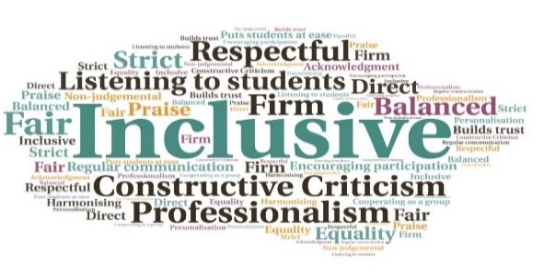  “I have received anecdotal comments from students on the value of the skills seminars, not only because they can ask questions in the live lecture, but also because they can dip into the recordings for a refresher or some new information.”  “I attended the skills sessions because they provided information about topics that I wanted to know more about. Particularly the ones like how to use the library search function, because that is a system that I use a lot for the course. They generally help me feel more informed about how UHI works.”  Supported students to develop general core skills | Covered additional topics such as careers and graduate attributes | Increased opportunity for students to seek support | Promoted a stronger student community | Provided rich additional online support with their studies, particularly as most on the Humanities Scheme attend via VC  Humanities Scheme Online Skills Seminars | Goal: To provide general, core skills to compliment subject-specific modules and support students in developing a substantial toolkit for their studies and beyond.  Submitted by: Iain MacInnes and Lucy Dean  Project: To provide 12 skills seminars per semester to increase student opportunities to seek support, develop skills, engage with staff and their peers, and develop a stronger student community.  Benefit to: Almost 600 students across the Humanities Scheme degree programme.  Key message: Improve core skills and provide support  Consolidate efforts to provide online skills support  Develop an organised programme of events to support student development  Cover basic skills used across all modules (i.e., essay writing, referencing)  Focus on foundational skills and support for careers/graduate attributes  Compliment subject-specific modules  Project delivery  Students can access the seminars live or asynchronously, via Webex  The programme is advertised via subject support modules on Brightspace  Sessions are led by a range of staff across the Humanities scheme, as well as experts from the Library Team and Careers Service for specific sessions  The seminars aimed to alleviate the effects of reduced access to college services which was encountered during the pandemic and lockdowns  More advanced sessions covered topics such as research ethics and advanced essay writing  Impact: The seminars worked in conjunction with Online Induction. Figures show the first seven sessions had 13-27 attendees, with up to 26 downloading the recording at a later time. There was renewed interest in the later weeks of Semester 1 and early Semester 2. Students reported appreciating being able to access the recordings for a ‘refresher’ after the event.

