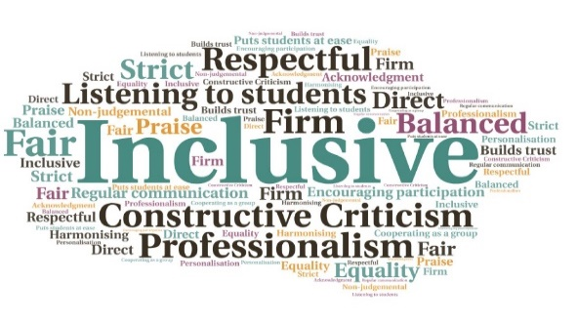  “The FutureMe podcast series aims to show career decisions not as problems to be solved but as amazing opportunities to be curious about.”  "The (Scottish) Parliament praises a University of the Highlands and Islands initiative to launch a new podcast series to help current students and graduates navigate their future career and employment options.”  A first for the university | Developed an online presence which tied in with existing key messages| Considerable focus on accessibility, with an accompanying transcript for each episode | Episodes coincide with key local, national, and international events | Includes wider student support such as mental health and resilience, alongside innovation, employability, and inspirational stories from different sectors  FutureMe Podcast  Executive Office  W | Goal: To engage students in an innovative and accessible way, interviewing industry professionals, staff, students, and alumni, to share career stories, experience, and advice.  Submitted by: Alana MacLeod  Project: To create a series of podcasts to help alleviate some of the effects of the Covid19 lockdown on students, and tie-in with the increased consumption of podcasts amongst the 15-24 age group since March 2020  Benefit to: All students and graduates  Key message: Promote careers and employability messages  Create a series of episodes with different key themes, expanding beyond just careers to include wider student support  Convey messages of positivity and resilience, and create collaborative content from a wide range of backgrounds/sectors  Share internal best practice with staff and students relating to podcast software and episode development  Engage with students in an innovative way, adapting to the different way of working during the Covid19 lockdown  Involvement from a broad range of sectors and businesses to represent the local and national labour market  Project delivery  Creation of two series worth of content, with Series 1 comprising 15 episodes and Series 2 comprising 11 episodes  Adopted a ‘drip-feed’ approach to promotion, to allow for weekly releases during the semester  Certain episodes released to coincide with key events, including student volunteering week, international mountain day, and international podcast day  Promoted careers and employability messages but also maintained communication around wider support, resilience and mental health  Ensured a positive narrative in a time when many were struggling with wellbeing and worried about short/medium-term career prospects  Impact: Between Sept 20-Feb 21, there were over 1,400 ‘hits’ for the webpage hosting the podcast, while statistics from SoundCloud showed a distinct spike at the launch of S1 and growing interest at the launch of S2. From LinkedIn alone there were over 3,000 views of podcast-related posts.

