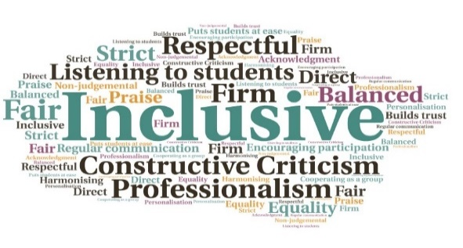  “I have overcome a barrier of the thought of trying something new! Getting up and into a routine was a struggle for me however this has given me the confidence to overcome the fear of a new challenge.’’  ‘’My confidence has grown massively in 6 weeks, the social aspect of coming to the skills academy has really helped with my mental health.’’  ‘’I hadn’t turned on a computer since 2008, this course has given me the skills and confidence to do that again.’’  Employability Challenge Fund  UHI Perth  W | Goal: To support applicants to look at future goals, including part-time or full-time employment and, where possible, continue some form of work-based learning.  Submitted by: Sarah-Jane Urquhart and Gareth McKenna  Project: To equip applicants to focus on reskilling or upskilling, focussing on developing employability and industry skills using various techniques and delivery methods.  Benefit to: Priority groups including care experienced, parents with dependents, long term unemployed, and school leavers with negative destinations.  Key message: Employment and/or continued education  Positive progression, academic or personal  Meeting personal goals  Considering future pathways  Developing a wide range of skills  Build confidence and develop motivation  Project delivery  Following a market research exercise with stakeholders, a range of industry sector academies were developed  Each academy was delivered by the relevant curriculum area, engaging with local employers  A busy and exciting timetable was established  The skills provision delivered was current and up to date, and beneficial in the existing job market  Weekly workshops helped build confidence, and work placements were included in some academies  Impact: Applicants had struggled since the pandemic, and these short industry courses helped them to develop motivation and gain new skills. Several have since had successful interviews leading to employment or entry onto college/university courses.
Students who had put their degree on hold during lockdown felt ready to resume their studies | Improved skills | Communication and team building | Engagement with local employability partners and employers | Learning about the job market and work skills | Helping applicants’ complete applications and create CVs

