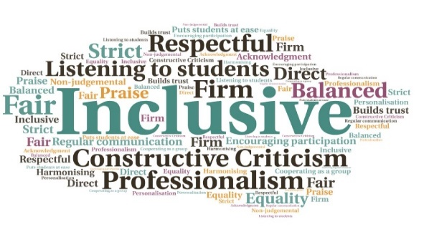  “As an engineering student I derive great value in the diversity of views and opinions the book club brings on a wide variety of student selected literature.”  "When I decided to join the college's Book Club, I thought only of reading more books in English and improving my language skills, but after all these meetings, laughs, new books and incredible discussions and debates, I can confidently say that I have gained much more than just books. “  Students who attend the clubs become good library users | Support from the Language School for ESOL club| Winner of the OBI award for best and most inspiring club in 2017 | Extra credits for ESOL students who attend the club| Funding from the Scottish Book Trust | Writing competition sponsored by UHI Libraries  Reading club project  Perth College UHI  W | Goal: Promoting literacy and exchanging ideas among students, proactively. Encourage reading, and introduce members to new authors and writing styles. Enable interaction between students and staff to debate a wide range of topics.  Submitted by: Maria Ramirez Jimenez  Project: To set up a book club to promote reading which would also allow students and staff to socialise with others from across a variety of courses. Students benefit by becoming more confident and learning to express their opinion in public, which provides intellectual stimulation and helps develop networking skills.  Benefit to: All students and staff  Key message: Promote literacy and the exchange of ideas  Work with the Library team and HISA to promote the club and encourage membership.  Help ESOL students through the creation of a separate club for members who do not have English as their first language.  Make the clubs available to the wider partnership by utilising VC facilities.  Create an environment where members are encouraged to express their opinions and debate a wide range of topics.  Encourage creativity by running writing competitions linked to the clubs, open to participants from all locations in the university.  Project delivery  Creation of an initial book club for students and staff. Additional clubs set up for ESOL students, and staff members.  Obtain funding from the Library team and HISA to buy books and promote the clubs.  Arrange author visits, open to external visitors, and organise activities related to Book Week Scotland.  Utilise VC facilities to allow students and staff to join the clubs from any location within the partnership.  Organise regular writing competitions, open to students and staff from all partners.  Impact: The clubs are available to students and staff from any academic partner, via VC. To discuss how this initiative could be beneficial to your community please contact Maria Ramirez Jimenez

