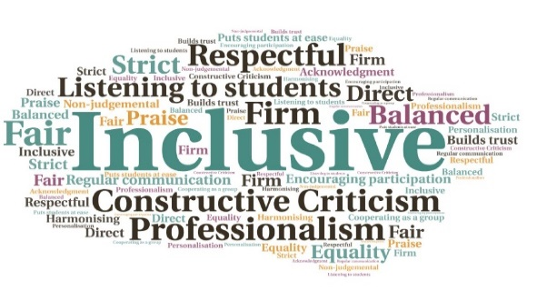  “Feedback from the students after the workshop was positive – they all appeared to find it interesting”  "The talk was fab, students really engaged and enjoyed it. Look forward to having (him) back again. “  All staff offered training, which will be on-going | Confidential referral system established with RASASH and Police Scotland| Powtoon presentation shown to all students at the start of term| Creation of a new Inverness College UHI student partnership agreement| Bystander intervention encouraged | Creation of a website with support information and an online reporting tool  #Itsnoton Campaign  Inverness College UHI  W | Goal: Challenging discrimination and sexual violence on and off campus, within the student body and the local community. Raise awareness and educate to stop these behaviours.  Submitted by: Claire Kilburn-Young  Project: To educate perpetrators, bystanders, and victims about sexual violence and acceptable behaviour. The aim of the project is to create a safer campus for staff and students, working in partnership with local agencies.  Benefit to: All students and staff  Key message: Prevention – Intervention - Response  Work in partnership with RASASH (Rape and Sexual Abuse Highland), Police Scotland, and Men in Recovery (A charity based support group for male survivors of sexual abuse).  Create a website with contact details for organisations who support victims of gender based violence, including an online reporting tool.  Educate students about acceptable behavior and clarify what is unacceptable, whilst embedding a zero tolerance approach.  Adopt an evidence based bystander intervention programme.  Address the government’s Equally Safe agenda by directly linking this campaign.  Project delivery  Members of the student services team to be trained with regard to dealing with disclosures.  Set up working group with RASASH, Police Scotland, and support staff.  Publish partnership agreements between students and the university to highlight behaviours which expected from students.  Create an online reporting tool.  Arrange workshops for students, including preventative workshops for male dominated courses and safe partying workshops for all students.  Impact: In the first year of the project the number of disciplinaries relating to sexual misconduct was reduced to zero. There were 3 instances reported by students and 2 instances reported by staff using the online reporting tool. To discuss how this initiative could be beneficial to your community please contact Claire Kilburn-Young

