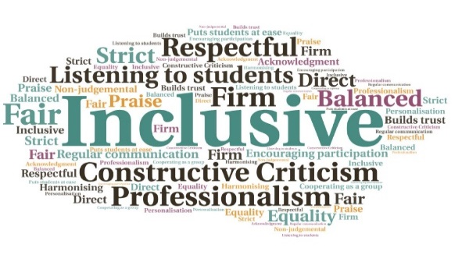  Emails include resources, psychoeducational tools, articles, quotes, and recommendations for websites/apps/podcasts/books | Useful way to support students who are solely online | Helped alleviate the impact of the pandemic on student’s mental health | Normalises use of the counselling services | Encourages students to try new ways to improve their mental wellness  “The newsletters and educational resources were very helpful and interesting too, in addition to being inspirational and sparking an interest in exploring topics one might not have thought of before.”  “Thanks so much for your wonderful kindness email! It is packed full of such great advice and lovely quotes. Reading it has made me so happy!”  Our Counsellors Recommend  UHI Perth  W | Goal: To reach out to the whole student population to offer support with the effects of the Covid pandemic, passing on valuable information and resources.  Submitted by: Claire Nelson  Project: Regular communication would help tackle the common themes and difficulties students were presenting with at counselling sessions. These emails would be full of inspiring, motivational, and encouraging content, designed for students to use to maintain or improve mental wellness.  Benefit to: All students  Key message: Support students on a wider scale  Complement the one-to-one sessions offered by counsellors  Deal with issues being experienced by a large majority of the student (and staff) body  Help those struggling with the impact of the pandemic, including feelings of isolation and loneliness  Alleviate the limitations of the counselling service; every student cannot be counselled, but valuable information and resources can be shared  Promote and normalise the counselling services on offer  Project delivery  Creation of a fortnightly newsletter, emailed to all students from the PC Student Wellbeing mailbox  Frequency is a good balance of keeping students engaged without overloading them, and allows time in between for resources and recommendations to be tried out  Content is produced by the full-time counsellors  Each newsletter covers new topics and resources, varying (as an example) from daily gratitude and self-kindness to self-care and grief  Students have engaged with the counselling service as a direct result of receiving these communications  Impact: Feedback has been positive, with a request that the emails be sent to all staff, too. This also allowed for content to be discussed in classes, additionally. Students meanwhile have requested counselling and made general queries to the counselling team after receiving these emails. The format allows for information to be shared with the whole student body, with practices which can be embedded into their daily lives.

