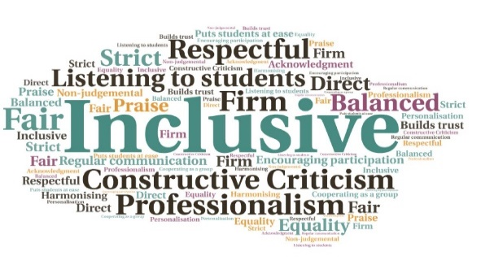  Builds on the success of the College Induction Module, Highly Commended in the 2021 SSI Awards |Allows students quick access to the Brightspace News and Events module | Useful method for disseminating important messages| Enhances the MyDay platform | Aims to tackle low student engagement for events | Reduces risk of key information being missed by students when circulated by email alone  News and Events Area Innovation  UHI West Highland  W | Goal: To enhance the MyDay platform, with a one-stop tile for providing news and events.  Submitted by: Anne Maree Dykes  Project: The aim was to increase student engagement by designing an area which all students, across all centres, would have access to.  Benefit to: All students  Key message: Ensure equivalence and increase student engagement  Effectively communicate with students, wherever they are based  Ensure students are kept up to date with news and events, without having to send numerous, lengthy emails  Allow for standardised, timely information to be provided to new and existing FE and HE students  Can be used by college staff and HISA  Inclusive for students who are distance learners and/or taught solely online  Project delivery  Creation of a new News & Events tile on the MyDay portal, linked to the module developed in Brightspace  Based on student feedback indicating a desire/need for a virtual noticeboard  Students were made aware of the tile during induction, and additional social media promotion has also taken place  Students can download the Brightspace Pulse App to access from a mobile device, and opt into notifications  Impact: Whilst analytical data is not yet available, feedback has indicated students have found the new feature to be straightforward, bright, and clear. Additional comments have remarked that getting information makes them feel ‘part of a community’ and it is ‘very easy to find and useful to have’.

