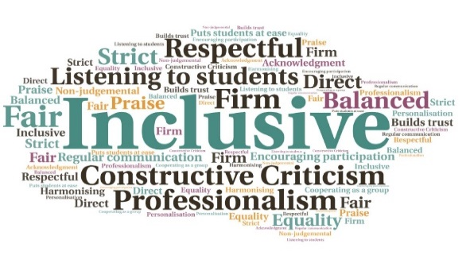  Look After Your Mate Training  HISA  W | Goal: To provide students from different geographical, cultural, and financial backgrounds with efficient tools to manage mental health and create a safe, understanding class environment.  Submitted by: Francesca Meneghetti  Project: To launch an initiative to help students define mental health, understand specific scenarios and how to deal with them, learn to prioritise wellbeing, understand the challenges of college/university, and complete accredited Mental Health Training.  Benefit to: All students  Key message: Allow students to gain an understanding of mental health dynamics and support strategies  To get students thinking about mental health and wellbeing, and effectively deal with challenges  Deliver accredited Mental Health Training  Provide an understanding of the basic dynamics people can struggle with  Actively involve students in brainstorming sessions  Ensure as many students as possible had access to the sessions  Project delivery  Multiple sessions were run, with the accredited training delivered via Microsoft Teams  The material was delivered with a light-hearted yet focused and efficient method, striking a balance of listening, talking, and sharing  Students had the opportunity to get to know one another, and listen to each other’s stories  Provided students with self-care techniques  Enabled participation for students from any location  Encouraged empathy and kindness, and letting go of self-judgement  Impact: Sessions had between 5-10 attendees, which was a good level of engagement during the pandemic. Students were given the chance to learn about a topic which is dangerously real in the current climate, gaining basic tools to deal with mental health difficulties. All necessary safe precautions were taken to ensure participants were not distressed by the subject matter.

