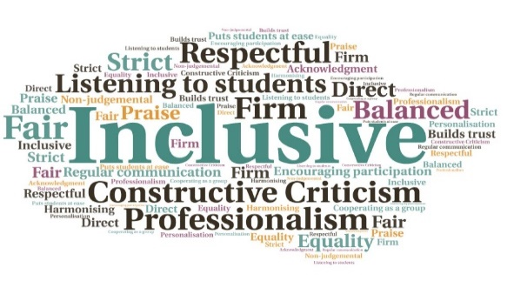  “In an age where more and more of us are working remotely, the Toolkit provides an innovative, intuitive, and inclusive resource in that it brings together all the strands of supporting learners and colleagues together, which is unique and accessible.” (External needs assessor)  “It really is a fantastic resource that small teams absolutely have come to rely on where we have limited access to wider experience and expertise locally”. (Academic Partner Head of Student Services)  Retention of students who would otherwise have left their studies | Addresses an identified training need for staff | Supports equivalence of student experience | Ensures consistent implementation of university disability processes | Covers legislative context | Provides guidance on implementing disability processes, including signposting and referral  Inclusive Practice Toolkit  Executive Office  W | Goal: To support the consistent implementation of university disability processes, thus promoting consistency of practice and student equivalence. The project also aimed to support teaching staff and others to reflect on and adjust their own practice, with inclusion and accessibility in mind.  Submitted by: Mark Ross  Project: To create a toolkit which would support the partnership to reduce avoidable local variations in the processes by which reasonable adjustments are implemented for students with declared disabilities and additional support needs, and elevate awareness of inclusive practice more widely  Benefit to: Student support practitioners, academic staff, students with disabilities or additional support needs, the wider student population  Key message: Ensure equivalence of student experience  To equip practitioners with the professional judgement necessary to assess and support student need  Provide standardised staff guidance and FAQs  Emphasise legal duties to implement reasonable adjustments for disabled students  Provide practical examples of inclusive and accessible practice  Impact positively on the student experience – for disabled students and the wider student population.  Project delivery  Creation of a new Toolkit, in two parts, in consultation with external contacts and staff across the partnership  The Toolkit was created by the Educational Development Unit (EDU) as an interactive online resource  Phased rollout, to disability practitioners and other staff including Personal Academic Tutors  Impact: The benefits of – and need for – the resource has been recognised at senior management level as well as externally. It is envisioned that the resource will be relevant as continuing professional development for new and existing staff, alike. The resource will be reviewed and updated annually, with usage monitored via analytics data. The current set-up allows staff to dip in an out of content as often as required, and could allow for compulsory completion in the future.

