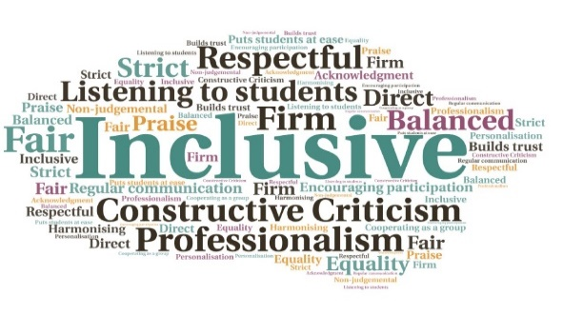  “Communicating with a graduate assistant has helped me continue to manage my studies and help me find new ways of prioritising workload.”  “Really enjoy the study skills sessions, it refreshes your mind and different questions always come up.”  “I think the most helpful thing was the GAs. Really reassuring and approachable.”  100% of students surveyed would recommend the 1 to 1 sessions | Weekly tutorials cover a vast array of topics, all included within the module assignments | Tutorials increased critical thinking and student’s confidence | Cohort have averaged roughly 5% higher than previous years| Availability across a number of platforms allows for proactive communication | Function for chat or video calls allows students to communicate in the way they feel comfortable  Graduate Assistants  UHI Inverness  W | Goal: To enhance and improve the delivery of both courses, and provide personalised and degree specific help to students who need it.  Submitted by: Norman Wilson, Amy Hendon, and Bethany Needham  Project: To create a Graduate Assistant role to improve the student experience of the BSc Psychology Degree and MSc Psychology Conversion degree, by aiding students in their studies and provide help, guidance, and information.  Benefit to: Students on BSc and MSc Psychology Courses  Key message: Improve the student experience and enhance communication  To provide assistance to students in a group or individual setting  Work proactively within the team and alongside staff  Maintain a high level of academic delivery and communicate with students on various platforms  Develop projects to support the delivery of the degree  Deliver workshops to students and provide 1 to 1 support across both courses  Project delivery  Following the creation of the role, interviews were held in February 2021 and the successful candidates began in March 2021  The role was shaped to fit each semester’s needs and the cohort of students  1 to 1 support provided help with deadlines, assignment planning, time management, and other worries/concerns  Weekly sessions discussed a vast array of academic skills  Increase in the amount of student/staff contact allowed students to discuss any concerns or problems and decreased social isolation  Weekly tutorials encouraged students to think critically about each theory, topic or research to aid in confidence and academic ability  Impact: Results from short surveys and general feedback indicate the impact has been across three areas; communication, connection, and confidence. There is a consistently high percentage of students with a declared disability on both courses, so tailored, personalised help that is degree specific has been highly beneficial.

