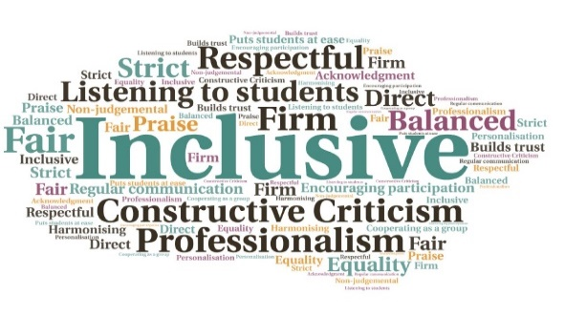  “What a benefit having access to all these resources nowadays! Managing the current situation is challenging in itself and embracing all the changes that this will induce is even trickier. So I am very thankful for the support.”  "I just wanted to say a huge thank you for the posts on social media over the holidays - what a great job in supporting the students- I enjoyed them too so thank you for all your hard work and effort. “  Helps students deal with immediate and long term pressure with appropriate techniques | Builds a positive work environment | Encourages problem solving and critical thinking skills | Ensures consistency in communication, across all platforms | Provides resources for staff to use to support students | Materials can be used across the partnership, to ensure equivalency  Wellbeing Content Intervention  Inverness College UHI  W | Goal: To coordinate the positive practices happening across the college and embed resilience, with active learning techniques and an effective ‘toolkit’.  Submitted by: Claire Kilburn-Young  Project: To ensure increased partnership approaches and collaboration, while also reducing duplication, and effectively communicate content to students.  Benefit to: All students  Key message: Promote wellbeing interventions  Coordinate communication of positive practices and share a variety of content  Develop links with the wider context of studying/working in a pandemic and the real-time effect on mental health  Embed resilience within an ongoing, sustainable programme  Ensure consistency  Share best practice across the wider partnership  Project delivery  A variety of e-content is released during the week to keep discussions active  Self-management booklets have been posted to students  Wellbeing workshops are offered live or are available as recordings with email support. These are also available for groups  Content is consistent across all platforms including Brightspace, social media, MyDay, Yammer and from frontline staff  Other academic partners have requested the information, which ensures students have access to the same resources  Impact: Students have been encouraged to develop problem solving and critical thinking skills, along with self-efficacy skills such as personal positivity and being flexible in the face of change. The resources have helped to reduce the anxiety and stress around the pandemic, and build a positive work environment. A number of academic partners have also taken up the content for use in Semester 2.

