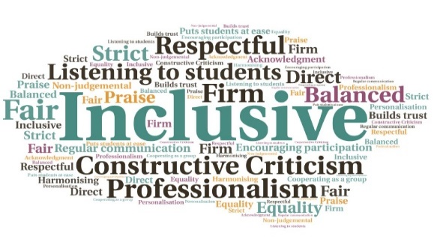  Regular attendance from 12-15 students at online sessions | Enabled continued contact between staff and students, to provide support as needed| Students have felt encouraged to contact staff if they have any issues | The initiatives replicate the social interaction which would happen on-campus | Aids the continued development of ‘soft skills’ which may have been lost with the switch to online learning | Gives students the opportunity to learn how to interact in a virtual space  “I enjoy being able to see people I have not seen in ages.”  "I like going in breakout rooms to have a catch-up with my friends “  “I enjoy it here because I can have a chat with everyone!”  “I really like being able to see everyone’s faces.”  SVS Social Hub  Perth College UHI | Goal: To help students with complex and challenging needs, on the SVS programme, with the development of ‘soft skills’, which has been impacted by the switch to online learning due to the pandemic restrictions.  Submitted by: Charlie Collie  Project: To create a bespoke initiative which will replicate the social interactions provided by on-campus learning and allow students to effectively interact with their peers in a virtual space.  Benefit to: Students on a specific programme  Key message: Provide support for students with complex and challenging needs  Provide the necessary support for students to manage effective social relationships, in a virtual setting  Address the isolation felt by this group of students due to lockdown  Combat the effect of the switch to online learning on the development of ‘soft skills’  Encourage continued student engagement while the campus is closed  In time, link with other academic partners to enable students to widen their social circle  Project delivery  Creation of a social hub on Brightspace where students can attend outside their classes  Organisation of events including an online quiz and discussions with specific themes such as movies, food, pets, etc  Future plans to link with another academic partner to allow interaction with students from the same environment at another institution  Impact: The students in this group have engaged well with the initiative, with regular attendance at the sessions. The relaxed atmosphere has allowed the development of organic, natural discussions, just as it would in person on campus.

