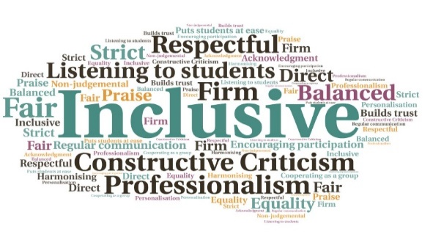  Better support for staff | Improved longitudinal inductions| Easier access from a wide range of devices | Improved navigation for students | Up to date content in sections such as UHI Technologies | Allows for online inductions for distance learners but also during unexpected events such as the recent pandemic  “I wish I had this when I first arrived to study in the UK. Students have, most of the time no idea what the University is waiting for in terms of writing, presentation, or any other kind of assignments and I quickly realised it wasn't only us foreign students, but also British students which is even more worrying. So yeah, great tool!”  "I accessed it before starting the course. I like that the explanations are short but informative.”  Improvements to Essential Student Skills  Executive Office  W | Goal: Refresh the content of the Essential Student Skills resource, including a new interface which can be used on all device types. The work was particularly timely, when Covid19 restrictions prevented face to face inductions in September 2020 and a generic student induction site was also developed on Brightspace which could be contextualized as required.  Submitted by: Dr Rachel Erskine  Project: A collaborative initiative between staff from the Educational Development Unit (EDU) and Programme Leaders, mainly from the Applied Life Studies network, to update content and apply technical changes which would improve the accessibility of the resource for the wide range of devices now used by students.  Benefit to: All students and staff  Key message: Encourage use of the resource by students  Apply a new interface suitable for all operating systems and device types, with an interactive menu and a new search bar  Revise existing content and create new content in key areas, including Health and Wellbeing, Covid19, and Fees  Expand content for UHI Technologies, including the MyDay portal, Outlook and Office 365, and Brightspace  Create a guidance document on how to structure an online induction around the Essential Student Skills resource  Encourage a strong association between students and the resource, which begins at induction and can be referred to throughout their time at UHI  Project delivery  Creation of a project team managed by staff from the Educational Development Unit (EDU) with writing and reviewing undertaken by a selection of Programme Leaders  The resource was launched alongside the online Induction module on Brightspace  With the expected increased user base, going forward a list of revisions and requests for additional content will be managed by EDU via Sharepoint, for updating at regular intervals  The online induction module allows for contextualisation and has been particularly beneficial during the Covid19 restrictions and resulting campus closures  It was noted the project ran to time and met all key outputs, despite the additional external challenges during that same period  Impact: Initial statistics show the revised resource received more hits in Aug 20-Jan 21 than in the whole of 2019-20.

