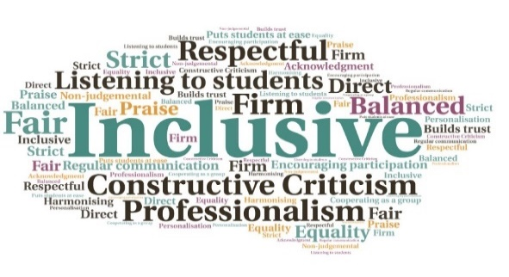  IT kit issues swiftly dealt with; 27 college laptops were provided on loan | Extra one to one support resolved technical issues such as access to lectures and Brightspace| 15 students were able to immediately apply for financial support, or guided to external agencies | Students were encouraged to access mental health resources such as Togetherall |Report provided to SMT to inform and guide actions, based on feedback | Students who were not engaging with classes were identified and supported  Student described the contact as “The best call of the day” and felt as though the university was concerned for their welfare.  Learning Centre staff felt more positive and stated, “It really felt like I made a difference”.  I Just Called To Say.. Are You OK?  Argyll College UHI | Goal: To ensure students felt supported during the period of enforced home learning.  Submitted by: Liz Richardson  Project: To communicate with students in a friendly, approachable manner which would offer far more benefit and personalisation than a standard email.  Benefit to: All students  Key message: Maintain communication with students during lockdown  Work with local staff to arrange phone calls to all students, highlighting the support on offer  Establish open lines of communication to encourage students to proactively engage with support services  Alleviate uncertainty around student’s learning during Covid19 pandemic  Ensure students felt valued and supported, despite move to online learning  Tackle issues including access to equipment, assessment worries, and financial concerns before they escalated  Project delivery  Staff divided student lists and spoke to 82% of students by telephone, on a wide range of topics  A script was written, for consistency, but staff adapted this to fit the situation and maintain a conversational tone  Students who required urgent support were quickly identified. This included IT kit issues, academic guidance, mental health, and funding  Student concerns were triaged, and staff were able to respond rapidly with targeted support  Students responded positively to the chance to talk to a real person at a time when they were feeling under pressure and uncertain  Impact: The calls allowed staff to be proactive and deal with a wide range of issues in a timely manner, ensuring students could successfully continue their studies from home. The students overwhelmingly reported feeling ‘valued’ and appreciated the personal touch.

