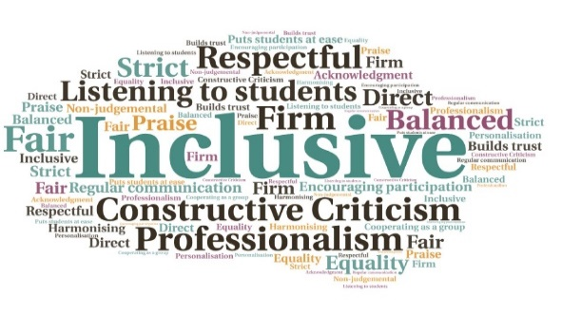  “I had the best time! Normally in the winter months, I tend to go outside a lot less than usual, snuggle up warm in cosy with a cup of tea and a book. But the project motivated me to go out at least once a day. I loved seeing all the photos of other explorers, aren't we blessed in Scotland? The project also motivated me to do a proper wildlife photography class to improve my skills, so thank you for everything.”  "Keep promoting this type of event to get more people involved and exploring the great outdoors and what a difference it can make to physical and mental health. Well done “  100 explorer packs distributed | Creation of an online discussion group, which has continued | Future green-based initiatives planned as a result of the project | Useful contact with student body for future engagement | Increase in outdoor activity and connection with nature for those who participated  HISA Nature Explorers Project  HISA  W | Goal: Encourage students to explore the Scottish wilderness and improve mental health during the pandemic.  Submitted by: Emma Robson  Project: To circulate a number of free explorer packs to students, as an incentive for students to get outdoors. Run in conjunction with online competitions with various prizes.  Benefit to: All students  Key message: Encourage outdoor exploration to improve mental health  Provision of 100 free explorer packs consisting of useful accessories such as a pedometer, poncho, and magnifying glass  Online competitions, with prizes, with categories such as Best Wildlife Photo and Best Green Selfie  Collaboration with existing societies, the Shetland Green Team and the Sustainable Development Society, during planning process  Online interaction via social media  Project delivery  The explorer packs were sent out to all those who applied, with the target met  50 participants joined a Facebook discussion group, which remains active to date  Participation in the online competitions was also high, with significant engagement on social media  Students reported an increase in confidence in exploring the outdoors, and local lockdown guidance was adhered to  The project is springboard for more green-based initiatives in the future, with a student-led and professionally supported conference planned for World Earth Day on 22nd April 2021  Impact: Students reported feeling motivated to go outside and connect with nature in their local green areas. It also improved student’s confidence in exploring, and increased engagement with the student’s immediate surroundings.

