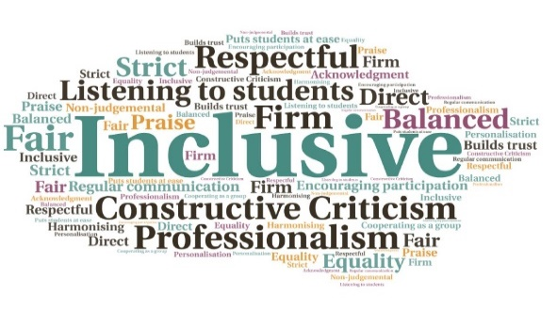  500+ students provided with IT resources | Includes laptops and dongles, for internet connectivity | Ensured students could engage with their studies from home | Ensured continued access to resources such as library services and the VLE while campuses were closed | Sessions delivered to improve student’s understanding of IT systems and VLE | New embedded processes will ensure incoming students have the necessary IT equipment available to them  Digital Poverty Project  Perth College UHI | Goal: Provide all students with the necessary equipment to study and work from home during lockdown.  Submitted by: Deborah Lally  Project: To identify students in need of equipment and provide the necessary resources as soon as possible.  Benefit to: All students  Key message: Provide equipment to enable home study  Creation of a survey to collect the required information from students  Assessment of available IT resources, including laptops and dongles  Creation of a system to monitor loans, and track and chase returns  Liaise with key staff to identify students in need of IT resources  Going forward, have systems in place to ensure all students have adequate resources to support their studies  Project delivery  Staff volunteered to support the survey, using both the online form and contacting students by telephone  The Library Management System was utilised to keep track of loans, and monitor and chase returns  Personal Academic Tutors (PATs) helped identify students who required IT equipment  Promotion of Bring Your Own Device (BYOD) was introduced, along with an addition to the Admissions Feedback Form which captures IT requirements for new students. This will also be added to the enrolment process  In addition, sessions were held on accessing Brightspace and general use of IT systems  Impact: The large number of students who were provided with resources have been able to successfully continue to study during the ongoing restrictions, and this has helped to prevent suspension or withdrawal. In the future, the new processes will ensure all incoming students have the necessary IT equipment to support their studies.

