Forge training session: Nov. 3rd, 2022
LTA Connect

An introduction

What is Forge?
Forge is an html creation tool – in a nutshell, it allows you to create rich, structured electronic content – ideal for uploading to Brightspace. Resources are navigated via a clickable list of contents on the left side of the resource. Being cloud hosted, anything you create and save is safe and can be edited from anywhere. Responsive design and accessibility also built in… but more of that later.
It’s the richness that’s the key – if you simply copy and paste your word doc into Forge, you’d be just as well uploaded the word doc to Brightspace; however, if when recreating the content in your Word doc you realise that your students would benefit from a video at a certain point, that you’d like to reduce the amount of scroll/ the amount of content on screen at any one time, or if you want to direct [link] them to activities, then Forge can help you to take your Word document to a higher level.

Where is it found?
Forge is cloud-based (a UHI ‘core’ service). You can either bookmark its url: https://forge.uhi.ac.uk or there’s a tile within MyDay (see Academic Services) or there’s a showcase ‘All About Forge’ on the EDU SharePoint site (the showcase includes worked examples).
Logging in: https://forge.uhi.ac.uk (It’s a core service, so requires normal UHI credentials)

Dashboard
When you first log into Forge you are taken to a dashboard with three tiles.
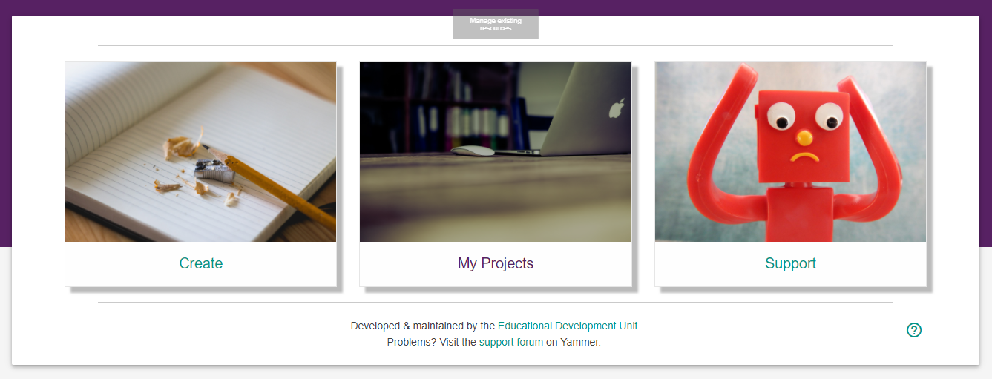
Figure 1: Forge Dashboard
- Clicking on the 'Create' tile will produce a new resource with a single page ready to edit.
- The 'My Projects' tile will allow you to manage existing projects created within the resource designer, along with exporting zipped packages which can be uploaded to the VLE.
- The 'Support' tile is where you will find guidance in the form of a Forge resource - it's a good idea to keep the guide open in a separate tab for quick reference.

My Projects
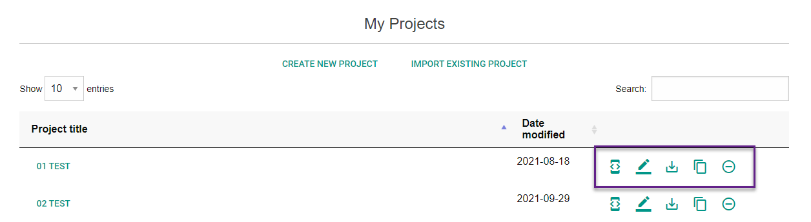
Figure 2: My Projects
- Clicking on the properties icon opens the project properties. You can add a project description and keywords which may be useful in the future to allow sharing and searching across resources.
- The edit resource icon opens the resource in the editor where you can make changes to the structure, content or included files within a resource. You can also enter edit mode by clicking on the resource name.
- Clicking on the export project icon brings up 3 options:
  - HTML5 package converts your project into a zipped package with a single index page which can be uploaded to the VLE.
  - Selecting Content only pages converts your resource into [multiple] single html files for the VLE.
  - Project backup icon allows you to export the entire project into a single file (.edurb) which can shared with colleagues who can import this file into their own projects area to edit and reuse. It's also a useful backup file for archive purposes.
- The clone project icon allows you to create a duplicate of a project.
- The delete will remove this project from the server. Be careful as all files uploaded to this resource space will be deleted.
You can return to the main dashboard or log out using the links at the top of the page.

Creating a project
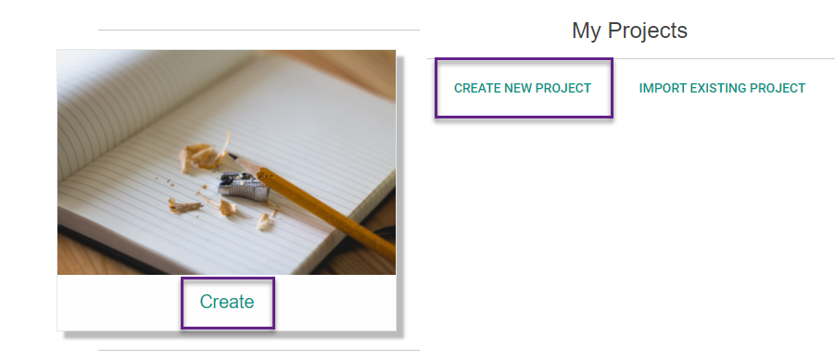
Figure 3: Creating a new project
You can create a new project from the Create tile or from the My Projects tile.
NB: Before you get too far into the creative process it’s a good idea to work out some of the broad strokes of what you want to accomplish in your source document (be it a Word doc or similar).

Structure
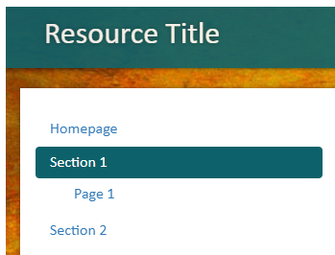
Figure 4: Sections and sub-sections
Although there are ways to further split up content*, Forge has only two levels of page structure (as shown in the picture above): sections and sub-sections**. Use heading styles (in your source doc) to determine your pages and sub-pages.
Accessibility – thinking of structure and making use of heading styles draws attention to accessibility (heading styles help those using screen readers), and what you can do in advance of developing your resource in Forge, e.g. if you have images, prep the alt text (Forge will ask for it); figure numbers etc. can also be added using the Caption option.
*Accordions (and accordions within accordions), as well as tables and responsive layouts can be used to further sub-divide content
**Right-click on resource or section/page name to edit

Background/ Theme
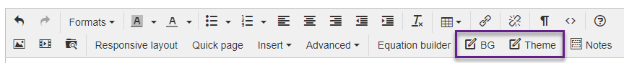
Figure 5: Changing background or theme in Forge
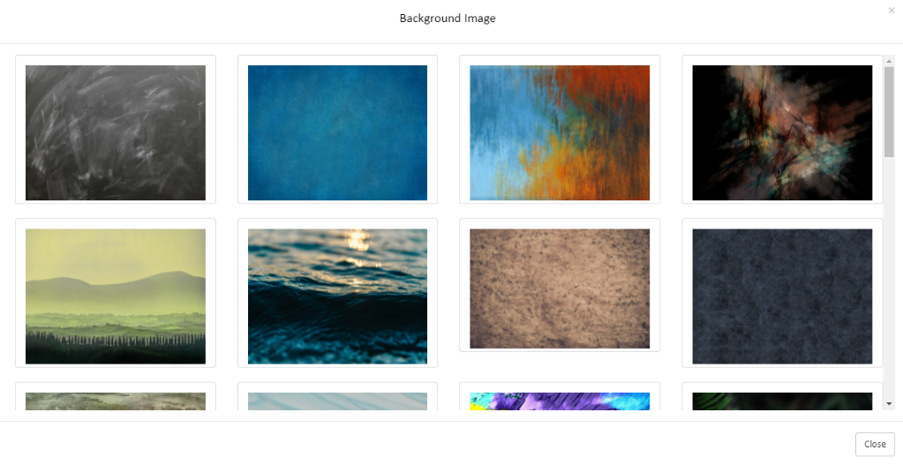
Changing the background or theme is an easy win in terms of personalising your resources: choose from 30 background images to show behind and to the sides of your written content; as well as 6 themes.
Figure 6: Selecting a background image

Preview
Figure 7: Preview and Save & Exit options
Preview function - versatile (improved in 2021), shows 3 different page sizes and can be expanded to fill a new tab.

Save & Exit
Crucial. Safety first.

Moving beyond the basics

Homepage/ Cover image
*Tip: use PowerPoint Design Ideas to create a professional looking initial image for a resource (or set of resources) (In PowerPoint: new > blank presentation > insert picture…save as .jpg/.png)
Figure 8: Copyright free image
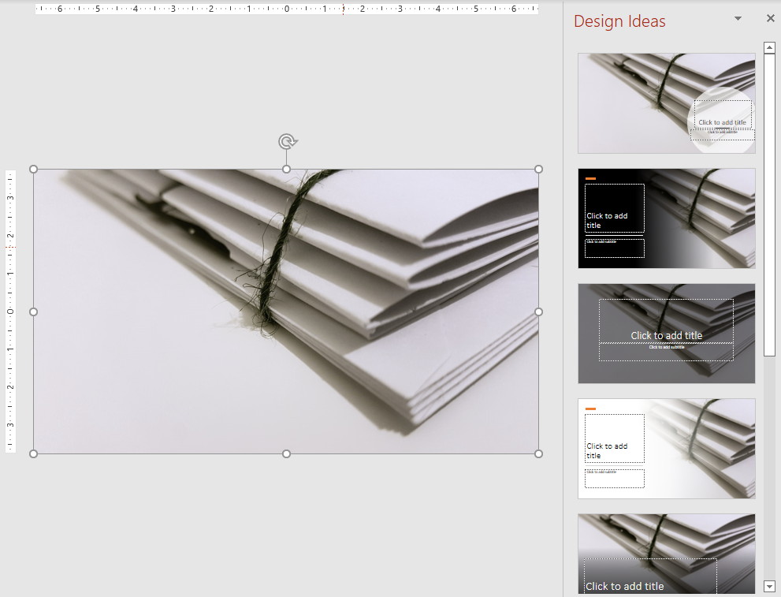
Figure 9: Image added to PowerPoint with Design Ideas on the right
Figure 10: The finished image

Background/ Theme
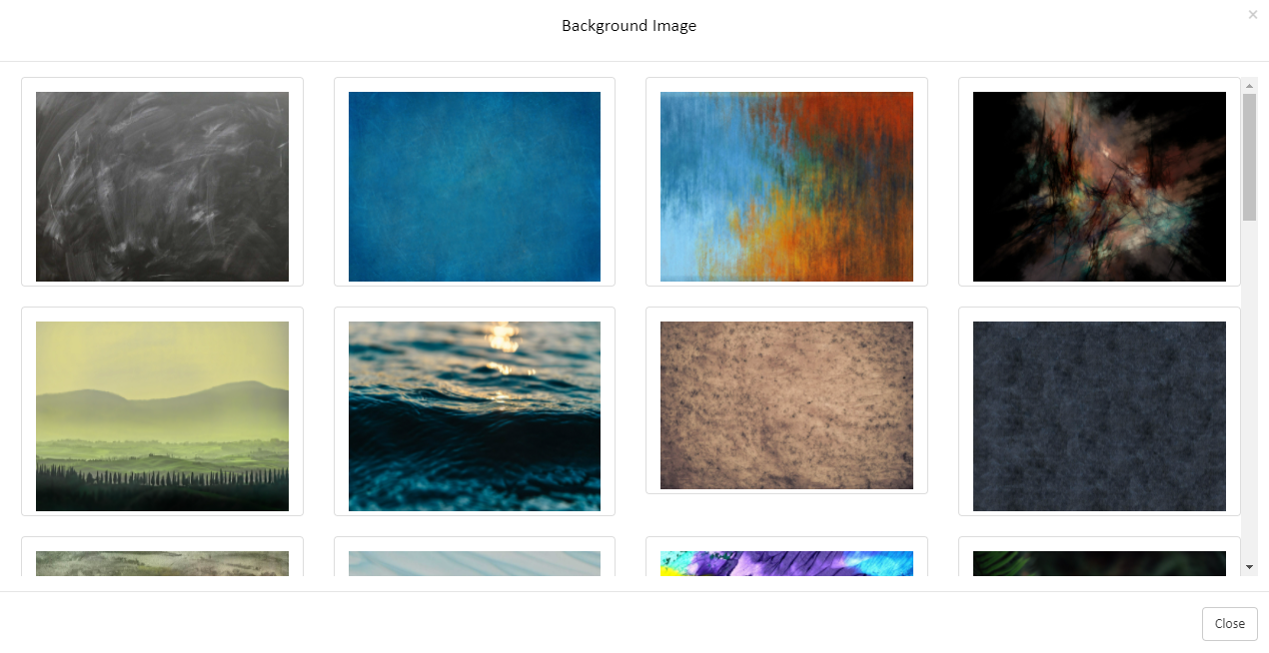
Figure 11: Background image options in Forge
Changing the background or theme is an easy win in terms of personalising your resources: choose from 30 background images to show behind and to the sides of your written content and/or change the colour of the bars at the top and bottom of the page (theme).

Responsive layouts
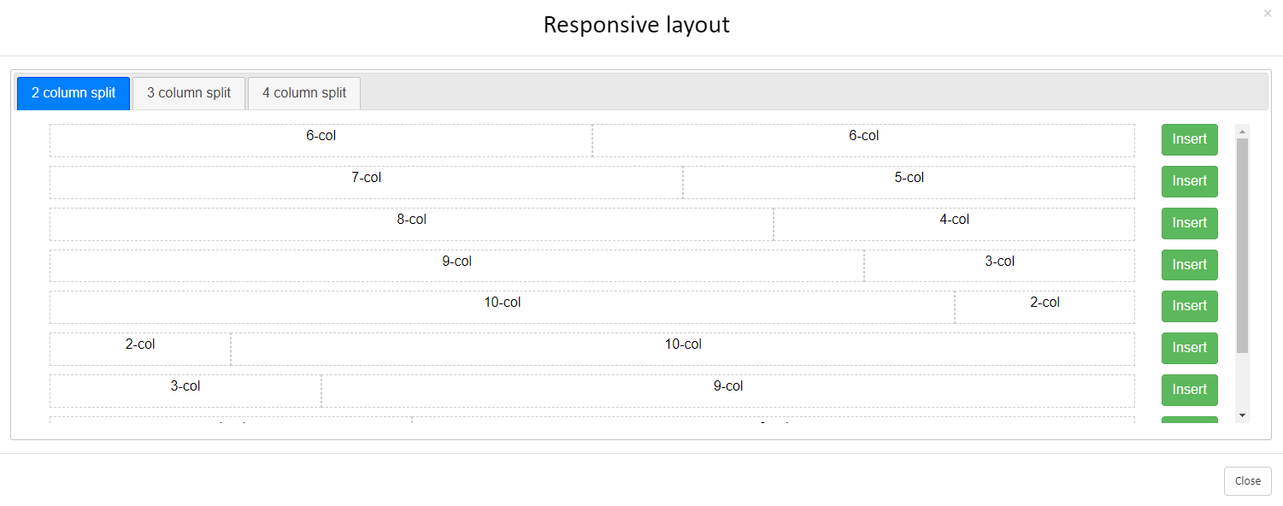
Figure 12: Responsive layout options
One of the most useful features of Forge (in the opinion of some!) are responsive layouts, where you can select to split your page into 2, 3 or 4 columns (*tip: if used in tandem with icons and alerts/colours the impact can be rewarding).

Images/ video embeds
Two powerful icons in the navigation bar: Manage/insert Files and Image properties.
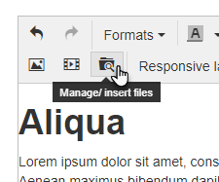
Figure 13: Manage/ insert files icon

The full process for uploading an image to Forge after clicking Manage/ insert files is: Select the Images folder (1), then click Upload (2) and locate the image (3). After that a thumbnail of the image will appear, click on that (4) to add it directly to your page.
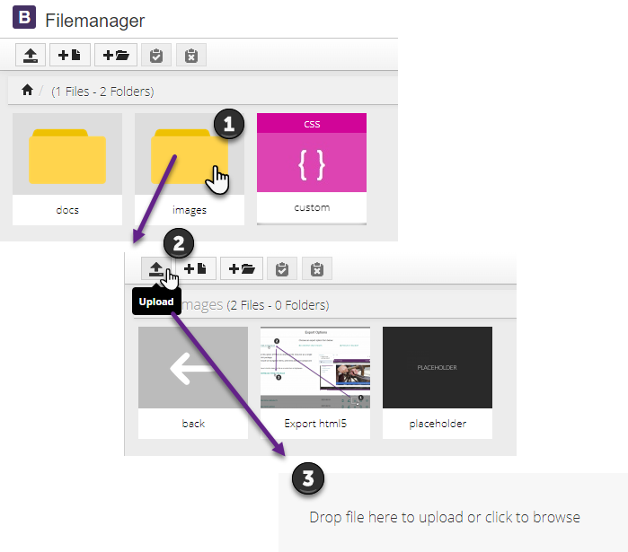
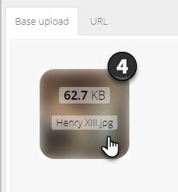
Figure 14: Uploading an image to Forge

There are many sources of copyright free images, Pexels (https://www.pexels.com/) and Pixabay (https://pixabay.com/) are two good ones.

Image properties
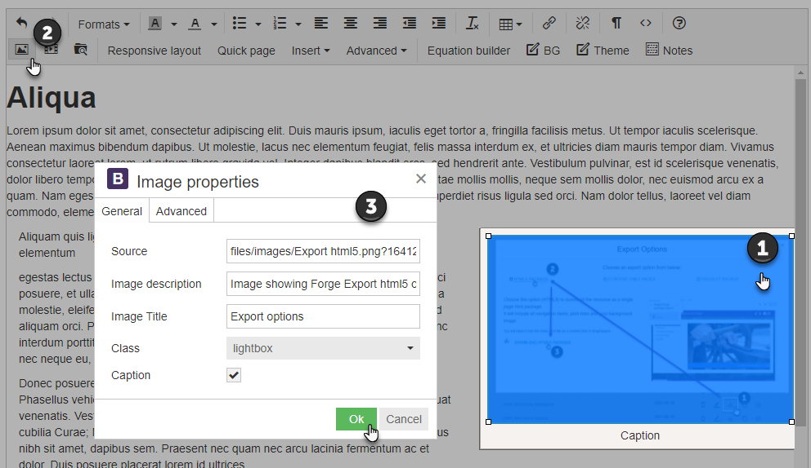
Figure 15: editing image properties
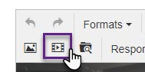
Video: Insert/edit media
Figure 16: Insert/edit media button
The middle of the three icons – perfect for displaying online video content in your resource. Our advice would be to use embed code if possible (in YouTube you can find this via the Share button, same goes for the UHI streaming server). Simply position the cursor on you page then click on Insert/edit media > Embed and paste the code in. Your users will now see an active video window (much better than a simple link).

Accordions
1 to 99. Multiple ways of using accordions – breaking up small sections of content; step by step guidance; lists of questions (FAQs *if you also use Click to reveal then students can get immediate feedback); glossaries, etc.
If the first accordion contains a relatively small amount of content, consider having it open automatically, otherwise remove check mark to end up with a list of clickable heading (e.g. below).
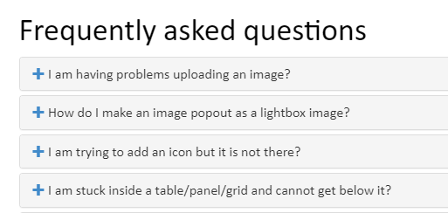
Figure 17: Using accordions for FAQs
*Tip: use an icon to further draw attention to unexpanded accordions (need a character space in front of text and not have heading highlighted to add an icon – the icon itself is not clickable but the text is).
*Tip: Use code view to remove ‘in’ so first accordion doesn’t open automatically.
*Tip: Although it seems that 2 is the minimum number of accordions, you can click on ‘2’ and change it to 1 manually if desired.
*Tip: You can have accordions within accordions – but be careful you don’t take this concept too far.

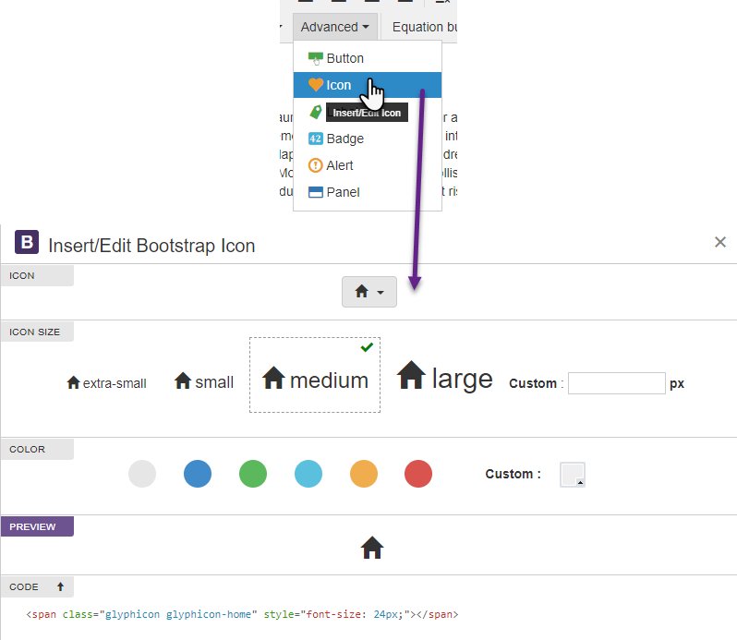
Icons / Alerts / Panels
Icons
Click on Advanced > Icons
201 icons to choose from – 4 sizes – any colour – preview feature
Icons can add real value and offer users a consistent shorthand for recognising particular types of content. Another option for consistent messaging is to use coloured alerts or panels.

Figure 18: Inserting an icon

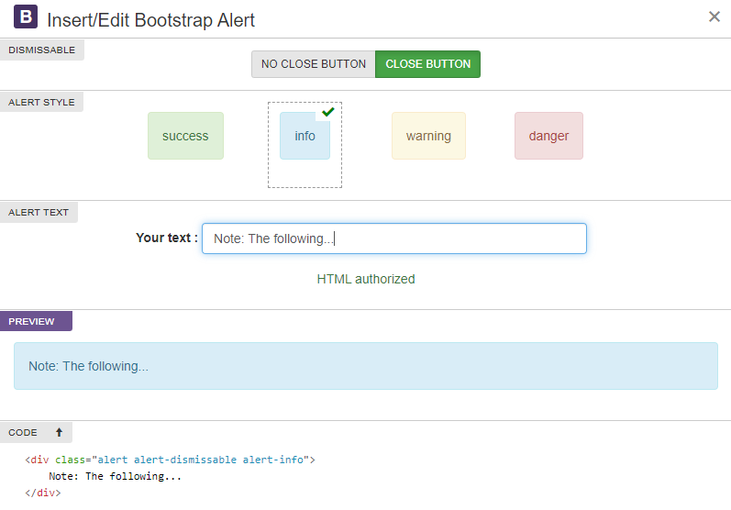
Alerts
Figure 19: Alerts options
Click on Advanced > Alerts/Panels
The text in alerts is by default a version of the colour of the box itself (e.g. a light blue panel will feature dark blue text – see above). This can be changed – simply highlight the text and select Text colour from the editor.

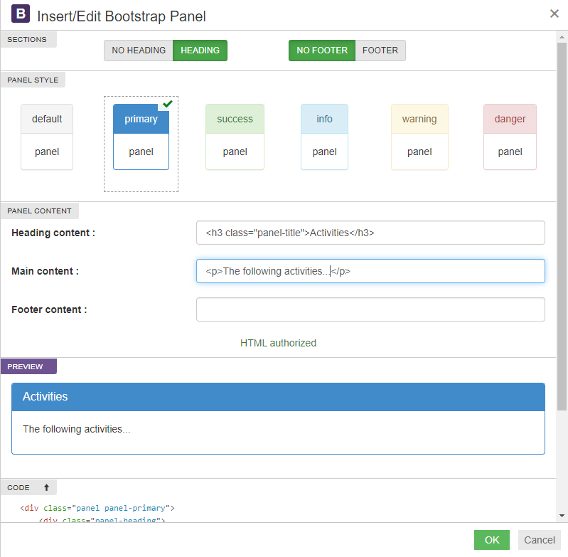
Panels
Figure 20: Panel options

Note: Carefully applied (same colours for same things) panels in resources can provide users with immediately recognisable themed content (activities, discussions, readings, videos… in tandem with alerts which cover other repeated types of content: notes, important notes, warnings, etc.)

Tables
Content already in a table can be copied and pasted into Forge without much trouble (easiest when the content is text and/or figures). But tables can also be created form within Forge.

Formatting

Quotes
One of the formatting options in Forge is ‘Blockquote’ (Formats > Blocks > Blockquote) – this indents and enlarges text, as well as bringing in a different typeface in order to draw attention:
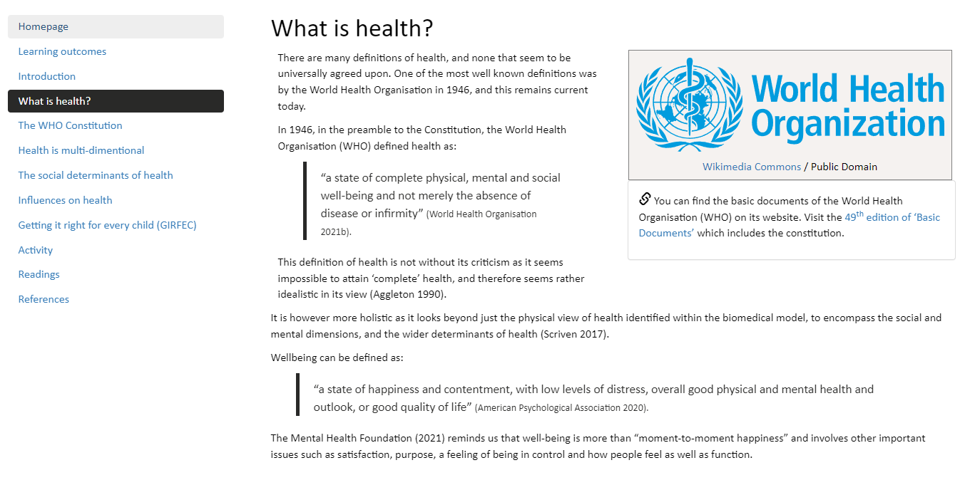
Figure 21: Page with quotes

Headings
If using a heading at the top of a page, the style must be heading 1 (Blackboard Ally will mark you down otherwise!).

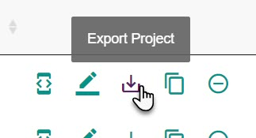
Moving into Brightspace
As mentioned above in My Projects, in the My Projects area of Forge (where you see the list of all the projects you’ve created), to the right of each there are various icons (Project properties etc.) – the middle one of these is Export Project.
Use this button to:
Figure 22: Export project
- Download a backup (.edurb file) of your resource; and/or
- Download an HTML5 package (this takes the form of a .zip file – and this is what you need to move your resource into Brightspace).
I won’t extend this document unnecessarily as there’s a well-illustrated guide on how to upload html resources to Brightspace in the EDU Support Portal: Uploading html packages to Brightspace (and making them open in new windows).
Any questions – edu@uhi.ac.uk

