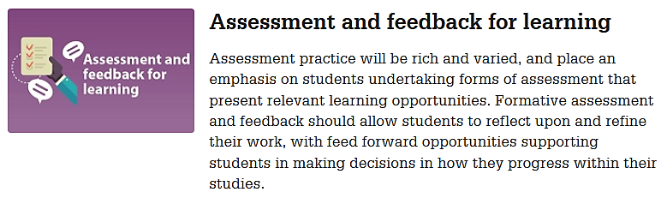
Using Brightspace for formative assessment
UHI Learning and Teaching Enhancement Strategy
How I (could) implement this value in my teaching
Learning Objective
Summative Assessment
Formative Assessment
(Brightspace) tool used for formative assessment

